**Program No: 01**

**Name: Sanio Luke Sebastian**

**Roll No: 35**

**Batch: B**

**Date: 08-04-2022**

**Aim:** To study various DDL commands – CREATE,

ALTER, DROP, TRUNGATE, RENAME.

**Questions:**

* ***CREATE***

1. Table1: Deposit
   * Actno varchar2(5) primary key, first letter must start with ‘D’ cname varchar2(15) foreign key references customer
   * Bname varchar2(20) foreign key references branch amount number (8,2) not null, cannot be 0
   * Adate date
2. Table 2: Branch
   * Bname varchar2(20) primary key
   * City varchar2(30) not null, any one of Nagpur, Delhi, Bangalore, Bombay
3. Table 3: Customer
   * Cname varchar2(15) primary key,
   * City varchar2(20) not null
4. Table 4: Borrow
   * loanno varchar2(8) primary key / first letter must start with ‘L’ cname varchar2(15) foreign key references customer
   * bname varchar2(20) foreign key references branch amount number (8,2) not null, cannot be 0

* ***ALTER, DROP, TRUNGATE, RENAME***

1. Create a table emp with attributes empno number (4) as primary key, ename char (10), hiredate, salary, commission. And insert the given 5 rows of data.
2. Modifying the structure of tables
   1. Add new columns: sal number(7,2)
   2. Dropping a column from a table: sal
   3. Modifying existing column: ename varchar2(15)
   4. Renaming the tables: emp to emp1
   5. Truncating the tables:emp1
   6. Destroying tables:emp
3. Create a table stud with sname varchar2(20) primary key , rollno number(10) not null,dob date not null
4. Create a table student as regno number (6), mark number (3) check constraint (mark >=0 and mark <=100));
5. Create a table cust with(custid number(6) constraint unique, name char(10)

**Procedure & Outputs:**

* ***CREATE***

1. CREATE TABLE customer ( cname VARCHAR (15), city VARCHAR (20) NOT NULL, PRIMARY KEY (cname));

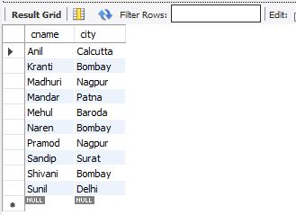

1. CREATE TABLE branch ( bname VARCHAR (15), city VARCHAR (20) NOT NULL, PRIMARY KEY (bname), CHECK (city IN ('Nagpur’, 'Delhi', 'Bangalore', 'Bombay'));

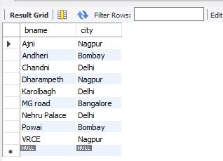

1. CREATE TABLE deposit ( actno VARCHAR (25), cname VARCHAR (15), bname VARCHAR (20), amount BIGINT NOT NULL, adate DATE, check (actno like 'D%'), PRIMARY KEY (actno), FOREIGN KEY (cname) REFERENCES customer (cname), FOREIGN KEY (bname) REFERENCES branch (bname), CHECK (amount > 0));

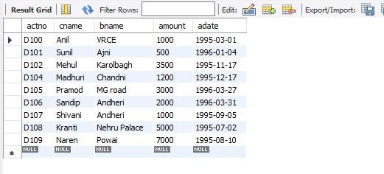

1. CREATE TABLE borrow ( loanno VARCHAR (25), cname VARCHAR (15), bname VARCHAR (20), amount FLOAT (8, 2) NOT NULL, CHECK (loanno LIKE 'L%'), PRIMARY KEY (loanno), FOREIGN KEY (cname) REFERENCES customer (cname), FOREIGN KEY (bname) REFERENCES branch (bname), CHECK (amount > 0));

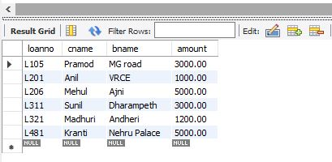

* ***ALTER, DROP, TRUNGATE, RENAME***

create database lab_cycle_three;

use lab_cycle_three;

1. CREATE TABLE emp (empno int(5), ename varchar(10), hiredate date, salary bigint, commission bigint, PRIMARY KEY (empno));

INSERT INTO emp VALUES (101,'Ramesh','1980-01-17',5000,null), (102,'Ajay','1985-07-05',5000,500), (103,'Ravi','1981-08-12',1500,null), (104,'Nikesh','1983-03-03',3000,700), (105,'Ravi','1985-07-05',3000,null);

select * from emp1;

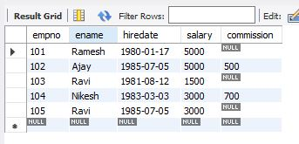

* 1. alter table emp add sal numeric(7,2);

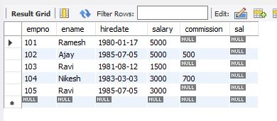

* 1. alter table emp drop sal;

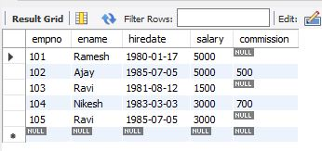

* 1. alter table emp modify column ename varchar(15);

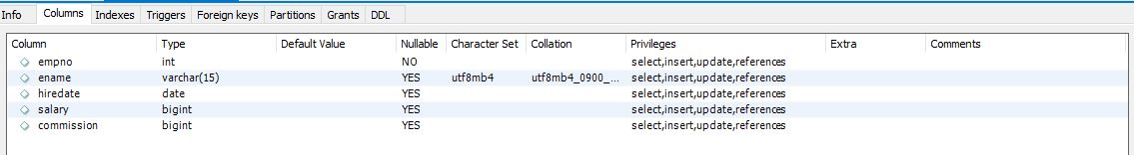

* 1. alter table emp rename emp1;

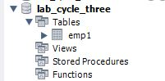

* 1. truncate table emp1;

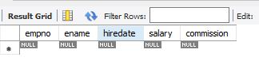

* 1. drop table emp1;

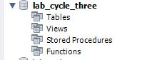

1. CREATE TABLE stud ( sname varchar(20), rollno numeric(10) not null, dob date not null, PRIMARY KEY (sname));

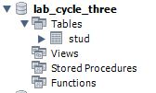

1. CREATE TABLE student ( regno numeric(6), mark numeric(3), check(mark >= 0 and mark <= 100));

